Tutorial: A/D and D/A Conversion on Altera Stratix EP1S25 Development Board using Simulink and DSP Builder

- Introduction

This tutorial could be used to get familiar with:
- The use of D/A and A/D converters on Altera Stratix EP1S25 development board
- Development of DSP algorithms using Altera DSP Builder in Simulink environment
- Implementing the algorithms in the onboard FPGA using the Signal Compiler utility in DSP Builder
- And, acquiring data from the board using the SignalTap II Analysis utility in DSP Builder

- Background

In the present laboratory, the students will learn how to model and simulate a simple hardware design using DSP Builder in the Simulink environment, to download the program to the FPGA on the Stratix EP1S25 DSP development board, and to perform hardware simulation and verification.

DSP Builder is a powerful tool from Altera that contains a library of basic hardware building blocks to develop, simulate and verify DSP algorithms in combination with Simulink system-level design tools. It also contains the necessary utilities to generate VHDL, Verilog HDL and Tcl scripts for synthesis, hardware implementation and hardware co-simulation. For complete details, please refer to [3] and [4].

The Stratix EP1S25 DSP development board is a powerful tool for digital signal processing designs. It contains a Stratix EP1S25 FPGA from Altera, and among several other components, two 12-bit 125MHz A/D and two 14-bit 165 MHz D/A converters, which will be mainly targeted in the present laboratory. For further information about the Stratix EP1S25 DSP development board, the student is referred to [1] and [2].

- Example design

The example design described in the present tutorial will be built in Simulink using DSP Builder. The design simply converts an analog signal to digital and transfers the result (with the required formatting) from the A/D to the D/A converter, which converts the signal back to analog. Figure 1 shows the design.

In the following pages, we will describe the steps required to develop this model and to set the required parameters. The design will be first modeled and simulated in Simulink, and then implemented and tested on the onboard FPGA.

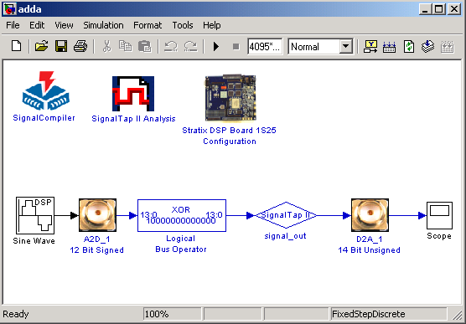
Fig. 1. A/D to D/A Example Design

Building the design model

- Open an Explorer window and create a directory where the design will reside.

NOTE: verify that there are no empty spaces in any folder’s name contained in the directory path. Otherwise, SignalTap II from DSP Builder will fail during execution.

- Open Matlab.

- In the Current Directory field on top of the Matlab window, set the recently created directory. Browse by using the button on the right.

- In the Matlab Command Window, type ‘simulink’ and press <Enter>, or alternatively, press the button on top of the window. The Simulink library browser will open in a new window (see Figure 2).

- The left hand side of the browser window shows the blocksets available in Simulink. Click on the sign beside ‘Altera DSP Builder’. A drop down menu will appear.

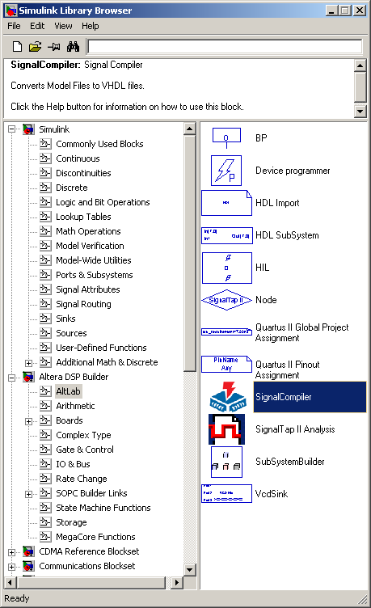
Fig. 2. Simulink Library Browser

- We now begin to create the design given in Figure 1. Click on ‘AltLab’. A set of blocks and utilities will appear at the right hand side of the browser window. Right click on the Signal Compiler block and select ‘add to current model’. A message will pop up. Click OK. The Signal Compiler icon will appear in a new model window. Save this empty model with a name in the recently created directory.

- Inside the Altera DSP Builder in the Simulink browser window, click on the sign beside ‘Boards’ and select ‘Stratix DSP Board EP1S25’. The relevant components of the board will appear at the right hand side of the browser window. Right click on ‘A2D_1 12 Bit Signed’ and select ‘add to <model name>’. The icon will appear in the model window. Left click on the icon. Hold the left button of the mouse and place the icon as appropriate. Alternatively, you can add components to the model window by dragging and placing blocks with the left button of the mouse.

- A2D_1 produces signed (two’s complement) signal whereas D2A_1 produces 14 -bit unsigned signal. When ‘offset two’s complement number’ is converted into decimal number, no jumps or discontinuities occur. The conversion is achieved by inverting the MSB. For further detail, please refer to [6]. Therefore to convert the signal coming from the A2D_1 into offset two’s complement, a ‘XOR’ operation could be used to invert the MSB.

In the Simulink browser window, select ‘Gate and Control’ from the Altera DSP Builder library. The relevant components will appear at the right hand side of the browser window. Right click on ‘Logical Bus Operator’ and select ‘add to <model name>’. The icon will appear in the model window. Left click the icon in the model window and hold the left click and drag the icon to align it to the right of A2D_1 as shown in Figure 1.

Double click on the ‘Logical Bus Operator’ icon. Type ‘14’ in [number of bits].[] field and ‘0’in [].[number of bits] field. Choose ‘XOR’ from the drop down menu of ‘Logical Operation’ field. Type ‘8192’ in the ‘Mask Value’ field and click OK.

- To connect the output of A2D_1 to the input of the Logical Bus Operator, left click on the A2D_1 icon in the model window, hold the <Control> key and left click on the ‘Logic Bus Operator’ icon. Alternatively, left click on the output of A2D_1, hold and drag it to the input of the Logical Bus Operator.

- Repeat step 6 to place ‘Signal Tap II Analysis’ and ‘Node’ in the model window. With the left button of the mouse, align both components as shown in Figure 1. Then, left click on the name ‘Node’ and change it by typing ‘signal_out’. Double click on the ‘signal_out’ icon and select ‘13’ and ‘0’ in MSB and LSB fields, respectively. Connect the output of ‘Logical Bus Operator’ to the input of ‘signal_out’ as described in step 9.

- Repeat step 7 to place ‘D2A_1 14 Bit Unsigned’ and ‘Stratix DSP Board 1S25 Configuration’ icons in the model window. Align D2A_1 with ‘signal_out’, and connect the output of the latter with the input of D2A_1.

NOTE: do not forget to save the design as often as necessary!

- The ‘Stratix DSP Board 1S25 Configuration’ icon allows us to select FPGA pins for relevant design signals such as clocks and reset. For this tutorial, we are using the onboard 80MHz crystal oscillator for clock signals and the A/D converter. To choose this option, double click on the ‘Stratix DSP Board 1S25 Configuration’ icon and choose ‘Pin_K17’ from the drop down menu for ‘Clock Pin In’ as shown in Figure 3. Make sure that the jumper is connected between pins 1 and 2 on the onboard connector ‘JP23’. With this setting, A2D_1 12 Bit Signed A/D converter will get the clock signal from the onboard 80MHz oscillator. Select ‘Pin_AE15’ from the drop down menu for ‘Clock Pin Out (D2A_1_CLK) field’ as shown in Figure 3. In this way, the built-in PLL in the FPGA clocks the D/A converter used in this design. Other parameters are not related with the design. Click OK to close the window. For complete details about clock distributions and options, please refer to [1].

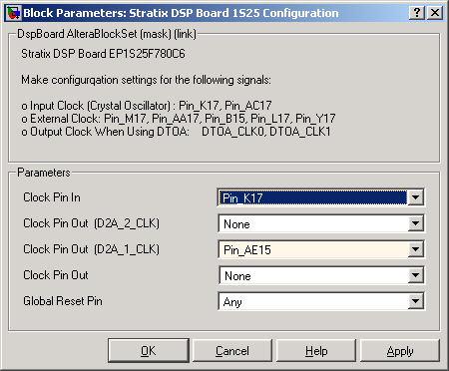
Fig. 3. Block parameters of the ‘Stratix DSP Board Configuration’ icon

Simulating the model in Simulink

- Left click on the sign beside ‘Signal Processing Blockset’ in the Simulink browser window. Left click the sign beside ‘DSP sources’ and drag and place the ‘Sine Wave’ block in the model window. Connect the icon with A2D_1. Double click on the ‘Sine Wave’ icon and set the parameters as shown in Figure 4. Then click OK.

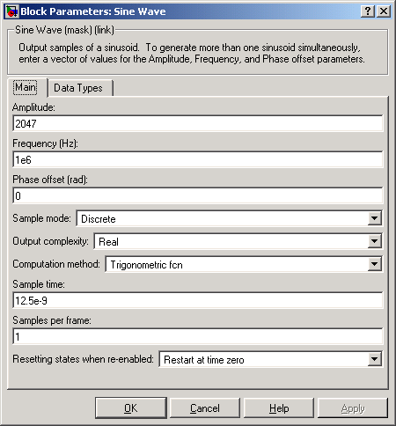
Fig. 4. Block parameters of the ‘Sine Wave’ block
- Left click on ‘Sinks’ in Simulink Library in the browser window and drag and place the ‘Scope’ block in the model window. Connect the ‘Scope’ icon with the output of D2A_1, as shown in Figure 1.

- Left click on ‘Simulation’ tab on the top of the model window and select ‘Configuration parameters…’. Set the parameters as shown in Figure 5.

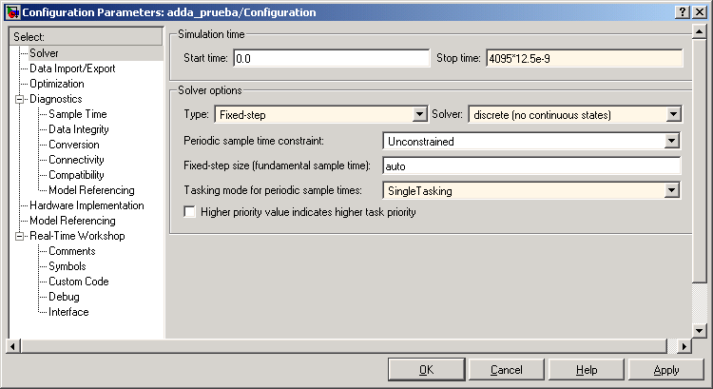
Fig. 5. Configuration parameters for the simulation

Start time: 0.0
Stop time: 4095*12.5e-9
Type: Fixed-step
Solver: discrete (no continuous states)
Tasking mode: Single Tasking

Click OK to close the Configuration window.

- In the model window, click on the button on the top of the model window. The simulation will start. Once the simulation is completed, double click on the

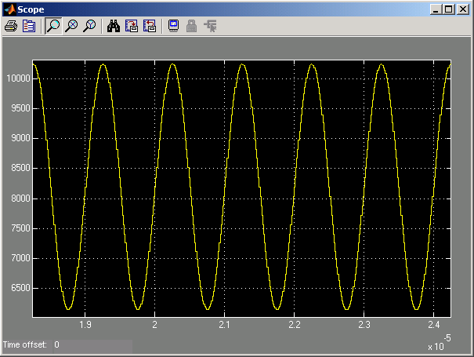
Fig. 6. Reconstructed sinusoidal signal after simulation
‘Scope’ icon to see the response. If the screen is empty, right click on the black screen of the ‘Scope’ and select ‘Autoscale’. You can augment, maximize and/or zoom in to have a better look of the sinusoidal signal (see Figure 6).

Implementing the model in the on-board FPGA

- Apply power to the Stratix EP1S25 board by connecting the 5V DC power supply adapter to connector J1. Power On LED D8 on the board must illuminate and a pre-programmed sequence is executed in the dual seven-segment display. For further information about powering the board, the student is referred to [1].

- Connect the yellow strip of the USB Blaster to JP17 on the board, verifying that pin 1, depicted on the yellow strip, is connected to pin 1 of JP17 (pin enumeration is printed on board, beside connector JP17). Then, connect the USB side of the USB Blaster to a USB port on PC.

NOTE: the USB Blaster must be previously assembled: the white cable connected to the main body of the USB Blaster.

If the ‘Found New Hardware Wizard’ window appears on PC, follow the next steps:
- Select ‘No, not this time’ and click ‘Next’ to continue.
- Select ‘Install the software automatically (Recommended)’ and click ‘Next’ to continue.
- A pop-up window appears. Click on ‘Continue Anyway’ and let the drivers for the USB Blaster be installed automatically.
- Click ‘Finish’ to close the window.

- Double click on the ‘Signal Compiler’ icon in the model window and click on the ‘Analyze’ button in the pop-up window. The Signal Compiler window will appear (see Figure 7).
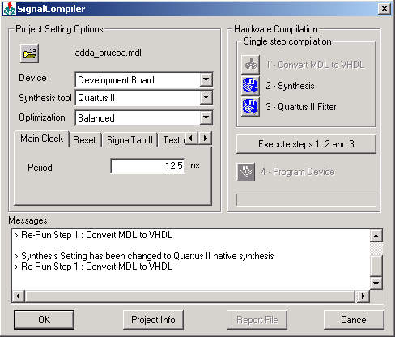
Fig. 7. Block Parameters of Signal Compiler
- Under Project Setting Options, select the following values of the parameters (see Figure 7):

Device: Development Board
Synthesis for: Quartus II
Optimization: Balanced

- Then, set the following parameters Under Project Setting Options (you can navigate through the different options by using the buttons ):

  - Select Main Clock and type 12.5 in the field.
  - Select SignalTap II, click the box on the right and select 1024 from the drop down menu of the Depth field.
  - Select Testbench and click the box on the right.
  - Select JTAG cable and verify that USB-Blaster appears in the ‘Select JTAG cable’ field.

- Under Hardware Compilation on the right of the Signal Compiler window, click on ‘Execute steps 1, 2 and 3’ and let the program run. The following processes will be executed automatically: conversion from MDL to VHDL, synthesis and Quartus II fitter.

When the process is done, check the Report by clicking on the ‘Report file’ button on the bottom of the Signal Compiler window. This file contains complete information about the program synthesis and fitting processes, as shown in Fig. 8. Then, close the Report.
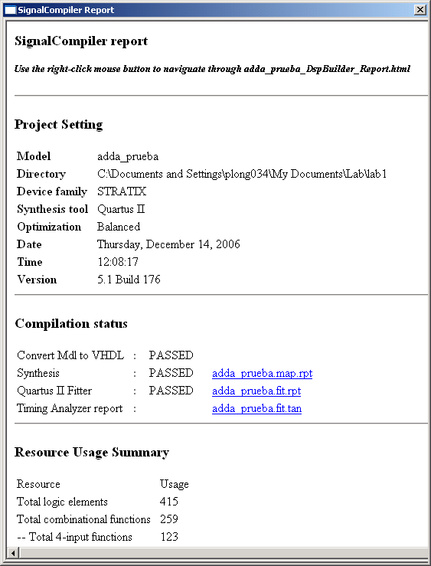
Fig. 8. Signal Compiler report
- Click on ‘Program device’ under Hardware Compilation in the Signal Compiler window. LED D5 on board will be turned off momentarily. When the program has been completely downloaded to the onboard FPGA, LED D5 illuminates and the message: “Quartus II programmer was successful” appears in the Signal Compiler window. Click OK.

Testing the design

For this part of the tutorial, we will require the next additional equipment: a signal generator and an oscilloscope. In addition, we will require two SMA cables (contained in the DSP Development Kit), and an extra cable to verify the output signal from the signal generator in the oscilloscope.

- Set the signal generator for Sine wave, select the frequency range at ‘5M’ and set 1MHz sine wave using ‘Coarse’ and ‘Fine’ tunings. Also, set the output level to 2V from -1V to 1V with the help of an oscilloscope for visualization (the extra cable will be required to connect the output signal of the signal generator to the oscilloscope).

- Connect the signal generator to the A2D_1 using a SMA cable (see [2] for more details) between the output of the signal generator and the SMA connector JP6 on the board.

- Connect a SMA cable between the oscilloscope and the SMA connector J2 on the board. A sine wave should be visible on the oscilloscope at 1MHz.

Analyzing the design using SignalTap II Analysis

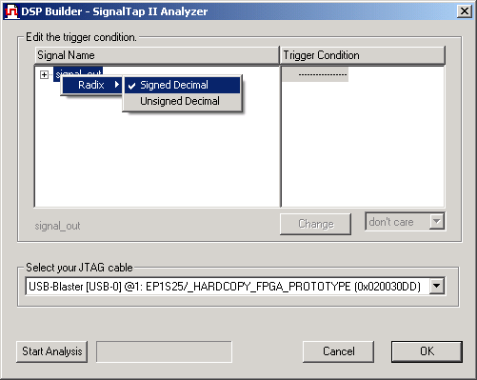
Fig. 9. SignalTap II Analyzer window

- Back to the model window in Simulink, double click on the ‘SignalTap II Analysis’ icon. Right click on ‘signal_out’ and select ‘Unsigned decimal’ as radix (see Figure 9).

- Click on ‘Start Analysis’ on the bottom of the SignalTap II Analysis window. It will start to acquire the data from the board. When done, a message will pop up. Click OK and two graphs will be shown after a while. Close the one that shows the activity on each bit of the observed signal ‘signal_out’. The other graph will show the complete signal in the selected radix. Zoom in on the signal. The ‘signal_out’ signal is a scaled version of the 1MHz sinusoid, and shown in Figure 10.

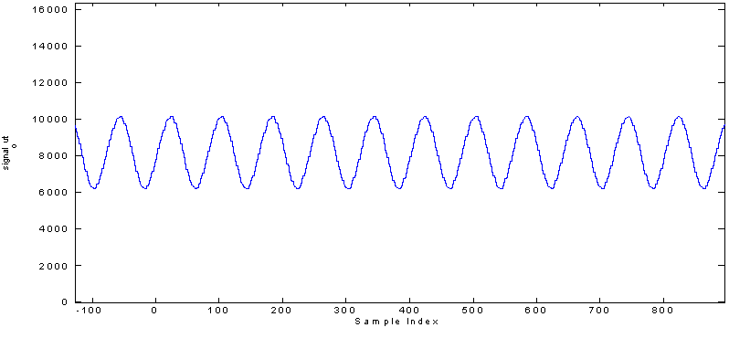
Fig. 10. Sine wave obtained using SignalTap II Analysis

Importing the data acquired from the board in Matlab workspace

- In the Matlab window, type the following command, and then click <Enter>:
<modelname>_tap_variables

The command runs a DSP Builder script that sends the SignalTap II data to the Matlab workspace.

- Type the next commands in the Matlab window to obtain a graph with the frequency response of ‘signal_out’:

x = length(signal_out)-1;
del_f = 80e6/x;
f = -40e6:del_f:40e6;
plot(f,abs(fftshift(fft(signal_out-8192))));

Figure 11 shows the frequency response using the data acquired from the board.

Fig. 11. Frequency response using data obtained from SignalTap II

- Conclusion

This tutorial is intended for serving as a template for the labs and demonstrating the DSP system-level design development of the Altera Stratix EP1S25 development board using Altera DSP Builder/Simulink. The reader is encouraged to review the reference design given in [5].

- References

For further details regarding DSP Builder, Altera Stratix EP1S25 development board and design examples using the mentioned tools, students are encouraged to review the next additional documentation:

[1] Stratix EP1S25 DSP Development Board Data Sheet, ver. 1.6, Altera, 2004. Available online at: http://www.altera.com/literature/ds/ds_stratix_dsp-board-starter.pdf or local copy at: c:\altera\61\kits\stratix_dsp_kit-v1.3.0\Docs\ds_stratix_dsp_bd.pdf

[2] DSP Development Kit Stratix & Stratix Professional Edition (Getting Started User Guide), ver. 1.3.0 rev. 1, Altera, 2004. Available online at: http://www.altera.com/literature/ug/ug_stratix_dsp_kit.pdf or local copy at: c:\altera\61\kits\stratix_dsp_kit-v1.3.0\Docs\ug_stratix_dsp_kit.pdf

[3] DSP Builder User Guide, ver. 5.1.0, Altera, 2005. Local copy at: c:\altera\61\DSPBuilder\Doc\ug_dspbuilder.pdf

[4] DSP Builder Reference Manual, ver. 5.1.0, Altera, 2005. Local copy at: c:\altera\61\DSPBuilder\Doc\mnl_dspbuilder.pdf

[5] Stratix Filtering Reference Design, AN245 ver. 3.0, Altera, 2004. Local copy at: c:\altera\61\kits\stratix_dsp_kit-v1.3.0\Reference _Design\filtering\Doc\an245.pdf

[6] Binary Numbering Systems (Application Note 83), AN83 ver. 1.0, Altera, 1997. Available online at: http://www.altera.com/literature/an/an083_01.pdf

Laboratory 1: Real-Time Implementation
for Observing Quantization Effects

- Introduction

In the present laboratory, the students are required to model and simulate a design using DSP Builder in the Simulink environment to demonstrate the quantization effects associated with the accuracy of data during analog to digital conversion. The design must be downloaded to the FPGA device on the Stratix EP1S25 DSP development board to perform hardware simulation and verification.

- Theory

Signals are naturally found in continuous range of values. In order to be processed by machines, these are first required to be sampled and then transformed to digital values. The latter is called quantization, and together with sampling, is mainly achieved by using analog-to-digital converters. The quantization level is specified by bits and the number of these has a strong influence on the quality of the digital signal.
In the present lab, we will see how the quantization level and the restriction in the accuracy of the digital data can play an important role in the quality of the transformed data.

- Background

Capabilities of DSP Builder and Simulink were introduced with an example design in the Tutorial: “A/D and D/A Conversion on Altera Stratix EP1S25 Development Board using Simulink and DSP Builder” [1].

The Stratix EP1S25 DSP development board is a powerful tool for digital signal processing designs that contains a Stratix EP1S25 FPGA from Altera, and among several other components, two 12-bit 125MHz A/D and two 14-bit 165 MHz D/A converters. Similarly to the Tutorial [1], the A/D and D/A converters will be mainly targeted in the present laboratory. For further information about the Stratix EP1S25 DSP development board, the student is referred to [2] and [3].

- Requirements

The basic design/verification flow using DSP Builder and Simulink system-level design tools was demonstrated in the Tutorial. The student must basically modify the design model given in [1] to accomplish the next requirements:

- Predefine 11 quantization levels by reducing the accuracy of the data by 0, 1, 2, 3, 4, …, 10 bits. To do this, you only need to take the 12 bits of data from the A/D converter, mask a given number (0, 1, …, 10) of the least-significant bits in order to reduce the accuracy of the quantized data, and then write the resulting data to the D/A converter to see the result. It is suggested to use the DIP switch SW3 onboard to select one quantization level at a time in real-time.

- Download the program to the onboard FPGA and test the design using the next equipment: a signal generator and an oscilloscope, two SMA cables (contained in the DSP Development Kit), and an extra cable to verify the output signal from the signal generator in the oscilloscope. Test the design with the next input signal:

Signal: Sine wave
Frequency: 1MHz
Output level: 2V, from -1V to 1V

You are required to demonstrate the performance of your implemented design. As number of bits is reduced, the resultant signal degradation should be visible on oscilloscope.

- Determine how many bits are required in order to have a signal quality close to the original 12 bits quality.

- Capture and analyze the data using SignalTap II Analysis. Again, determine how many bits are required in order to have a signal quality close to the original 12 bits quality.

- By default, the Stratix EP1S25 DSP development board works at a sampling rate of 80MHz. Modify your design and test it with a sampling rate of 1.25MHz, on oscilloscope and then using SignalTap II. Analyze and discuss the aliasing effect around the Nyquist frequency when the sinusoidal signal is increased through the range from 100KHz to 1.25MHz. Using data captured with SignalTap II, plot the frequency response of two signals that show the aliasing effect.
Both sampling rate options (1.25MHz and 80MHz) must be available in your final design. For that, use a Multiplexer and one of the available switches of SW3 (the first 4 switches will be used to select one out of 11 quantization levels, as explained in Example of masking, from 12 bits accuracy to 10 bits accuracy) to select in real-time one of the two sampling rates.

You could use the “template” model explained in the Tutorial. Only slight modifications are required to the model in order to achieve this first project.

Example of masking, from 12 bits accuracy to 10 bits accuracy

Connect the ‘Logical Bus Operator’ block from the Altera DSP Builder library to the A/D in the tutorial model. Select ‘AND’ as a logical operation and type ‘4092’ as a mask. It s equivalent to the following in C language:

in & 0xFFC

Outputs of these logical blocks could be multiplexed and one output at a time could be connected to the D/A converter using the selector input of the multiplexer. The SW3 (set of DIP switches) from the ‘Board’ library for the Stratix DSP Board EP1S25 could be used as the selector input. It is important to note that a switch in ‘OFF’ position sets the logic value ‘1’, and a switch in ‘ON’ position sets the logic value ‘0’. There are 8 DIP switches in SW3 that together drive an 8-bit bus. DIP switch0 corresponds to LSB. More details about the DIP switch could be found in [2] and [3].

Example of modifying the sampling rate

To have a multirate circuit you need to specify the additional sampling rates through the PLLs contained into the Altera FPGA. Then, two components from the Altera DSP Builder library (Rate Change) are necessary to introduce different sampling rates in your design: PLL and Tsamp. For instance, to sample the sinusoidal signal given in Figure 1 in the Tutorial [1] at a rate of 1.25MHZ, the next steps are required:

  - Add PLL and Tsamp blocks (in Rate Change) and Down Sampling block (in Storage) from the Altera DSPBuilder library, and connect them as shown in Figure 1. The Down Sampling block is needed because this particular design is purely combinatorial and such block forces the design to use the sampling rate specified by Tsamp.

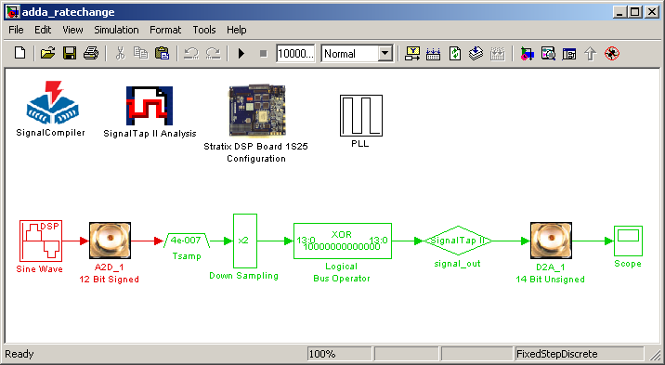
Fig. 1. A/D to D/A Example Design with a sampling rate of 1.25MHz

  - Configure the PLL by double clicking in the PLL icon. We need to specify all the frequencies to be used in the design (including the main clock frequency): 1.25 and 80MHz. Verify that ‘Input clock frequency’ is at 80MHz and the number of output clocks is 2. Leave ‘Output clock clk0’ from the drop down menu at 80MHz. Select ‘Output clock clk1’ and type 32 in the ‘Clock frequency division factor’ field. Verify that the configured periods for the PLL are 12500ps and 400000ps, which correspond to 80 and 2.5MHz, respectively, as shown in Figure 2. Then, click OK. Note that the sampling rate at 2.5MHz will be later downsampled to 1.25MHz as required.

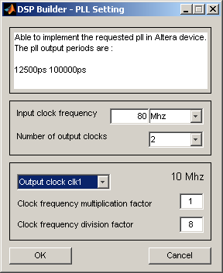
Fig 2. PLL configuration

  - Double click on the Tsamp block and type 1/2.5e6, corresponding to 2.5MHz, in the ‘Sample time’ field. Then double click on the Down Sampling block and type 2 in the ‘Down Sampling rate’ field. This will downsample the signal at 2.5MHZ from Tsamp to 1.25MHz. Finally, you can simulate the design, and see the effect of the sampling rate on signals at different frequencies.

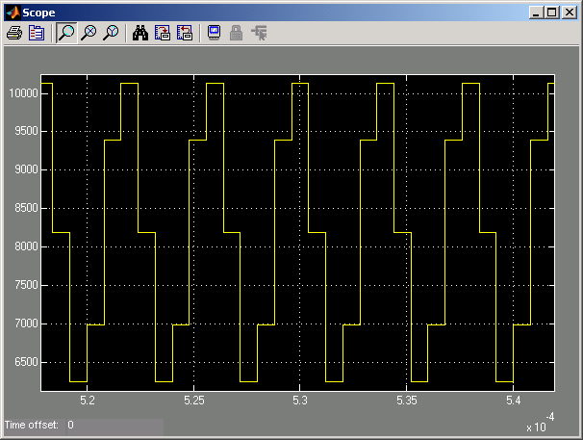
Fig 3. Reconstructed 1MHz sinusoidal signal after simulation

Figure 3 shows the results of the simulation with 1MHz sinusoidal signal. You can check the differences between this result with a sampling rate at 1.25MHz and the signal obtained (Figure 6, Tutorial [1]) with a sampling rate at 80MHz.

- Submission

You must submit:
  - The Simulink model (.mdl) developed using DSP Builder blocks, working with two sampling rates: 1.25 and 80MHz.
  - A report describing the general procedure to accomplish the project requirements and answering questions regarding quantization and aliasing effects as detailed in the requirements. The report must contain graphs showing the quantization effects using the data acquired via SignalTap II from the board for both sampling rates: 1.25 and 80MHz.

- References

[1] Tutorial: “A/D and D/A Conversion on Altera Stratix EP1S25 Development Board using Simulink and DSP Builder”.

[2] Stratix EP1S25 DSP Development Board Data Sheet, ver. 1.6, Altera, 2004. Available online at: http://www.altera.com/literature/ds/ds_stratix_dsp-board-starter.pdf or local copy at: c:\altera\61\kits\stratix_dsp_kit-v1.3.0\Docs\ds_stratix_dsp_bd.pdf

[3] DSP Development Kit Stratix & Stratix Professional Edition (Getting Started User Guide), ver. 1.3.0 rev. 1, Altera, 2004. Available online at: http://www.altera.com/literature/ug/ug_stratix_dsp_kit.pdf or local copy at: c:\altera\61\kits\stratix_dsp_kit-v1.3.0\Docs\ug_stratix_dsp_kit.pdf

