Tutorial: A/D and D/A Conversion on Altera Stratix II EP2S60 Development Board using Simulink and DSP Builder

- Introduction

This tutorial could be used to get familiar with:
- The use of D/A and A/D converters on Altera Stratix EP2S60 development board
- Development of DSP algorithms using Altera DSP Builder in Simulink environment
- Implementing the algorithms in the onboard FPGA using the Signal Compiler utility in DSP Builder
- And, acquiring data from the board using the SignalTap II Analysis utility in DSP Builder

- Background

In the present laboratory, the students will learn how to model and simulate a simple hardware design using DSP Builder in the Simulink environment, to download the program to the FPGA on the Stratix II EP2S60 DSP development board, and to perform hardware simulation and verification.

DSP Builder is a powerful tool from Altera that contains a library of basic hardware building blocks to develop, simulate and verify DSP algorithms in combination with Simulink system-level design tools. It also contains the necessary utilities to generate VHDL, Verilog HDL and Tcl scripts for synthesis, hardware implementation and hardware co-simulation. For complete details, please refer to [3] and [4].

The Stratix II EP2S60 DSP development board is a powerful tool for digital signal processing designs. It contains a Stratix II EP2S60 FPGA from Altera, and among several other components, two 12-bit 125MHz A/D and two 14-bit 165 MHz D/A converters, which will be mainly targeted in the present laboratory. For further information about the Stratix II EP2S60 DSP development board, the student is referred to [1] and [2].

- Example design

The example design described in the present tutorial will be built in Simulink using DSP Builder. The design simply converts an analog signal to digital and transfers the result (with the required formatting) from the A/D to the D/A converter, which converts the signal back to analog. Figure 1 shows the design.

In the following pages, we will describe the steps required to develop this model and to set the required parameters. The design will be first modeled and simulated in Simulink, and then implemented and tested on the onboard FPGA.

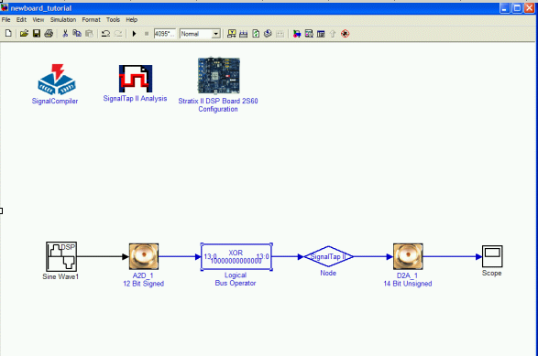
Fig. 1. A/D to D/A Example Design

Building the design model

- Open an Explorer window and create a directory where the design will reside.

NOTE: verify that there are no empty spaces in any folder’s name contained in the directory path. Otherwise, SignalTap II from DSP Builder will fail during execution.

- Open Matlab.

- In the Current Directory field on top of the Matlab window, set the recently created directory. Browse by using the button on the right.

- In the Matlab Command Window, type ‘simulink’ and press <Enter>, or alternatively, press the button on top of the window. The Simulink library browser will open in a new window (see Figure 2).

- The left hand side of the browser window shows the blocksets available in Simulink. Click on the sign beside ‘Altera DSP Builder’. A drop down menu will appear.

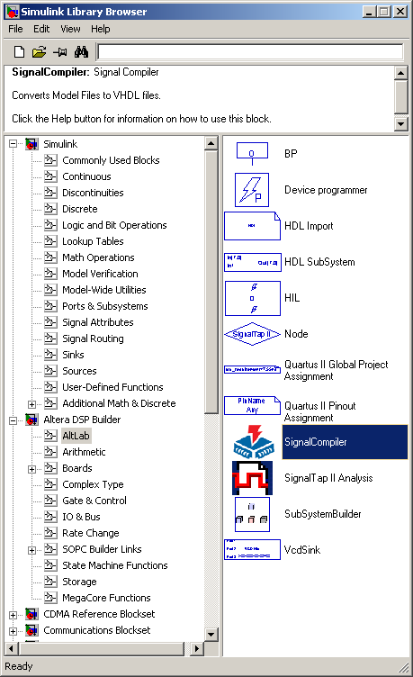
Fig. 2. Simulink Library Browser

- We now begin to create the design given in Figure 1. Click on ‘AltLab’. A set of blocks and utilities will appear at the right hand side of the browser window. Right click on the Signal Compiler block and select ‘add to current model’. A message will pop up. Click OK. The Signal Compiler icon will appear in a new model window. Save this empty model with a name in the recently created directory.

- Inside the Altera DSP Builder in the Simulink browser window, click on the sign beside ‘Boards’ and select ‘Stratix II DSP Board EP2S60’. The relevant components of the board will appear at the right hand side of the browser window. Right click on ‘A2D_1 12 Bit Signed’ and select ‘add to <model name>’. The icon will appear in the model window. Left click on the icon. Hold the left button of the mouse and place the icon as appropriate. Alternatively, you can add components to the model window by dragging and placing blocks with the left button of the mouse.

- A2D_1 produces a signed (two’s complement) signal whereas D2A_1 requires a 14 -bit unsigned signal. When an ‘offset two’s complement number’ is converted into a decimal number, no jumps or discontinuities occur. The conversion is achieved by inverting the MSB. For further detail, please refer to [6]. Therefore to convert the signal coming from the A2D_1 into offset two’s complement, a ‘XOR’ operation could be used to invert the MSB.

In the Simulink browser window, select ‘Gate and Control’ from the Altera DSP Builder library. The relevant components will appear at the right hand side of the browser window. Right click on ‘Logical Bus Operator’ and select ‘add to <model name>’. The icon will appear in the model window. Left click the icon in the model window and hold the left click and drag the icon to align it to the right of A2D_1 as shown in Figure 1.

Double click on the ‘Logical Bus Operator’ icon. Type ‘14’ in [number of bits].[] field and ‘0’in [].[number of bits] field. Choose ‘XOR’ from the drop down menu of ‘Logical Operation’ field. Type ‘8192’ in the ‘Mask Value’ field and click OK.

- To connect the output of A2D_1 to the input of the Logical Bus Operator, left click on the A2D_1 icon in the model window, hold the <Control> key and left click on the ‘Logic Bus Operator’ icon. Alternatively, left click on the output of A2D_1, hold and drag it to the input of the Logical Bus Operator.

- Repeat step 7 to place ‘Signal Tap II Analysis’ and ‘Node’ in the model window. With the left button of the mouse, align both components as shown in Figure 1. Then, left click on the name ‘Node’ and change it by typing ‘signal_out’. Double click on the ‘signal_out’ icon and select ‘13’ and ‘0’ in MSB and LSB fields, respectively. Connect the output of ‘Logical Bus Operator’ to the input of ‘signal_out’ as described in step 9.

- Repeat step 7 to place ‘D2A_1 14 Bit Unsigned’ and ‘Stratix II DSP Board 2S60 Configuration’ icons in the model window. Align D2A_1 with ‘signal_out’, and connect the output of the latter with the input of D2A_1.

NOTE: do not forget to save the design as often as necessary!

- The ‘Stratix II DSP Board 2S60 Configuration’ icon allows us to select FPGA pins for relevant design signals such as clocks and reset. For this tutorial, we are using the onboard 100MHz crystal oscillator for clock signals and the A/D converter. To choose this option, double click on the ‘Stratix II DSP Board 2S60 Configuration’ icon and choose ‘Pin_AM17’ from the drop down menu for ‘Clock Pin In’ as shown in Figure 3. Make sure that the jumper is connected between pins 3 and 4 on the onboard connector ‘J3’, and pins 5 and 6 are connected by a jumper on the onboard connector ‘J18’. With these settings, A2D_1 12 Bit Signed A/D converter and D2A_1 14 Bit Unsigned D/A converter will get the clock signal from the onboard 100MHz oscillator. Also, make sure to choose ‘EP2S60F1020C4’ from the drop down menu for ‘Device’ option. Other parameters are not related with the design. Click OK to close the window. For complete details about clock distributions and options, please refer to [1].

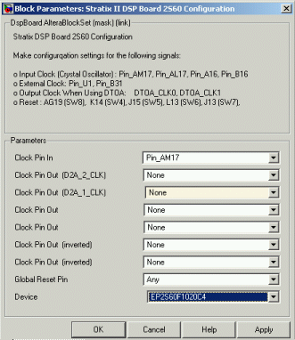
Fig. 3. Block parameters of the ‘Stratix II DSP Board Configuration’ icon

Simulating the model in Simulink

- Left click on the sign beside ‘Signal Processing Blockset’ in the Simulink browser window. Left click the sign beside ‘DSP sources’ and drag and place the ‘Sine Wave’ block in the model window. Connect the icon with A2D_1. Double click on the ‘Sine Wave’ icon and set the parameters as shown in Figure 4. Then click OK.

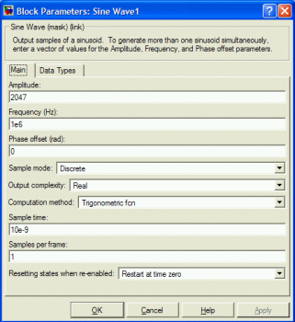
Fig. 4. Block parameters of the ‘Sine Wave’ block

- Left click on ‘Sinks’ in Simulink Library in the browser window and drag and place the ‘Scope’ block in the model window. Connect the ‘Scope’ icon with the output of D2A_1, as shown in Figure 1.

- Left click on ‘Simulation’ tab on the top of the model window and select ‘Configuration parameters…’. Set the parameters as shown in Figure 5.

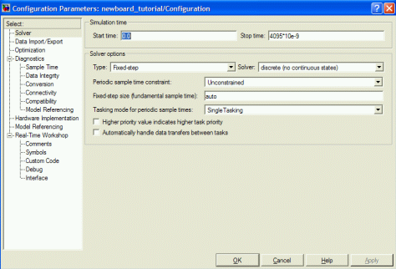
Fig. 5. Configuration parameters for the simulation

Start time: 0.0
Stop time: 4095*10e-9
Type: Fixed-step
Solver: discrete (no continuous states)
Tasking mode: Single Tasking

Click OK to close the Configuration window.

In the model window, click on the button on the top of the model window. The simulation will start. Once the simulation is completed, double click on the ‘Scope’ icon to see the response. If the screen is empty, right click on the black screen of the ‘Scope’ and select ‘Autoscale’. You can augment, maximize and/or zoom in to have a better look of the sinusoidal signal (see Figure 6).

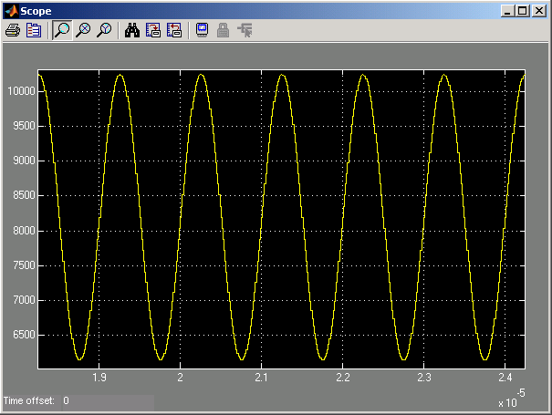
Fig. 6. Reconstructed sinusoidal signal after simulation

Implementing the model in the on-board FPGA

- Apply power to the Stratix II EP2S60 board by connecting the DC power supply adapter to connector J22. After the board powers up, the Stratix II device is programmed with the factory design stored in flash memory. After the device is programmed, LEDs D5 through D8 behave as a binary counter that counts down to zero. This is a power-up indication that the board is functional and the device was successfully programmed with the factory design.
- Note: If you do not see the LEDs behaving as described above shortly after power is applied to the board, disconnect power. Make sure that SW9 is swiched to “ON” and switch 4 on SW2 is in the “OPEN” position, then apply power to the board again.

- Connect the yellow strip of the USB Blaster to J21 labeled as “Stratix II” on the board. Be careful on the direction of the cable: the white line on the yellow strip depicted as “pin 1” should be on the side that is near the fan mounted on the FPGA device, as shown in Figure 7. Also DO NOT connect this yellow strip of USB Blaster to J13, which is right above J21 and labeled as “CONFIG JTAG”. Then, connect the USB side of the USB Blaster to a USB port on PC.

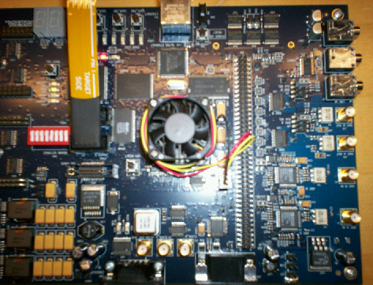

Fig. 7. The Connection of the Yellow Strip of USB Blaster

NOTE: the USB Blaster must be previously assembled: the white cable connected to the main body of the USB Blaster.

If the ‘Found New Hardware Wizard’ window appears on PC, follow the next steps:
- Select ‘No, not this time’ and click ‘Next’ to continue.
- Select ‘Install the software automatically (Recommended)’ and click ‘Next’ to continue.
- A pop-up window appears. Click on ‘Continue Anyway’.
- Click ‘Browse’ and specify the path ‘C:\WINNT\system32\drivers’ in the next pop-up window, then click ‘OK’, as shown in Figure 8.
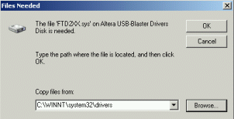
Fig. 8. The Driver Install of USB Blaster (1)

- Click ‘Browse’ and specify the path ‘C:\WINNT\system32’ in the next pop-up window, then click ‘Retry’, as shown in Figure 9.

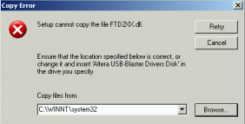
Fig. 9. The Driver Install of USB Blaster(2)

- Click ‘Finish’ to close the window.

- Double click on the ‘Signal Compiler’ icon in the model window and click on the ‘Analyze’ button in the pop-up window. The Signal Compiler window will appear (see Figure 10).
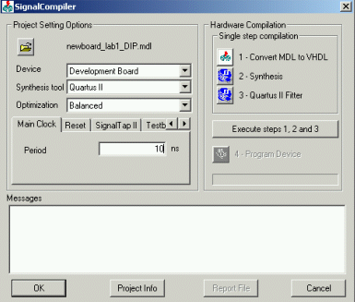
Fig. 10. Block Parameters of Signal Compiler

- Under Project Setting Options, select the following values of the parameters (see Figure 10):

Device: Development Board
Synthesis for: Quartus II
Optimization: Balanced

- Then, set the following parameters Under Project Setting Options (you can navigate through the different options by using the buttons ):

  - Select Main Clock and type 10 in the field.
  - Select SignalTap II, click the box on the right and select 1024 from the drop down menu of the Depth field.
  - Select Testbench and click the box on the right.
  - Select JTAG cable and verify that USB-Blaster appears in the ‘Select JTAG cable’ field.

- Under Hardware Compilation on the right of the Signal Compiler window, click on ‘Execute steps 1, 2 and 3’ and let the program run. The following processes will be executed automatically: conversion from MDL to VHDL, synthesis and Quartus II fitter.

When the process is done, check the Report by clicking on the ‘Report file’ button on the bottom of the Signal Compiler window. This file contains complete information about the program synthesis and fitting processes, as shown in Fig. 11. Then, close the Report.
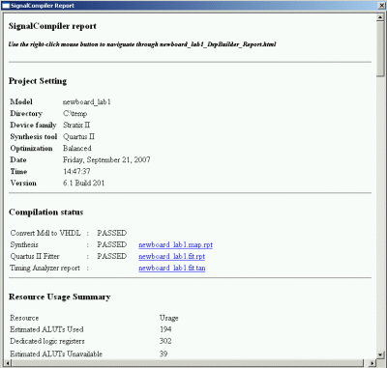
Fig. 11. Signal Compiler report

- Click on ‘Program device’ under Hardware Compilation in the Signal Compiler window. LEDs D5 through D8 on board will be turned on together momentarily. When the program has been completely downloaded to the onboard FPGA, LEDs D5 through D8 will be turned off and the message: “Quartus II programmer was successful” appears in the Signal Compiler window. Click OK.

Testing the design

For this part of the tutorial, we will require the next additional equipment: a signal generator and an oscilloscope. In addition, we will require two SMA cables (contained in the DSP Development Kit), and an extra cable to verify the output signal from the signal generator in the oscilloscope.

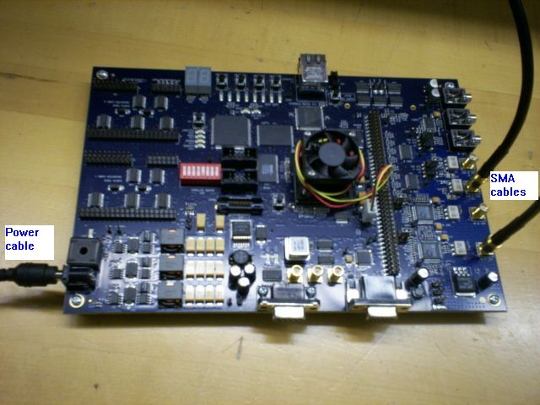

- Set the signal generator for Sine wave, select the frequency range at ‘5M’ and set 1MHz sine wave using ‘Coarse’ and ‘Fine’ tunings. Also, set the output level to 2V from -1V to 1V with the help of an oscilloscope for visualization (the extra cable will be required to connect the output signal of the signal generator to the oscilloscope).

- Connect the signal generator to the A2D_1 using a SMA cable (see [2] for more details) between the output of the signal generator and the SMA connector J1 on the board.

- Connect a SMA cable between the oscilloscope and the SMA connector J15 on the board. A sine wave should be visible on the oscilloscope at 1MHz.

Analyzing the design using SignalTap II Analysis

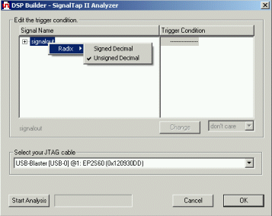
Fig. 12. SignalTap II Analyzer window

- Back to the model window in Simulink, double click on the ‘SignalTap II Analysis’ icon. Right click on ‘signal_out’ and select ‘Unsigned decimal’ as radix (see Figure 12).

- Click on ‘Start Analysis’ on the bottom of the SignalTap II Analysis window. It will start to acquire the data from the board. When done, a message will pop up. Click OK and two graphs will be shown after a while. Close the one that shows the activity on each bit of the observed signal ‘signal_out’. The other graph will show the complete signal in the selected radix. Zoom in on the signal. The ‘signal_out’ signal is a scaled version of the 1MHz sinusoid, and shown in Figure 13.

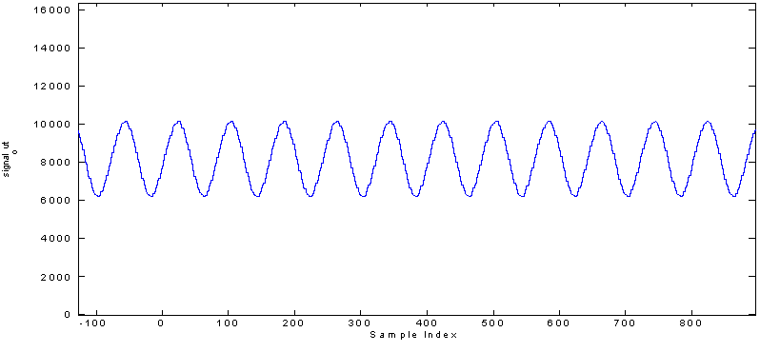
Fig. 13. Sine wave obtained using SignalTap II Analysis

Importing the data acquired from the board in Matlab workspace

- In the Matlab window, type the following command, and then click <Enter>:

<modelname>_tap_variables

where "modelname" is the name given to the model, and "_tap_variables" is the name of the variables that we want to import (for example "signal_out").

The command runs a DSP Builder script that sends the SignalTap II data to the Matlab workspace.

- Type the next commands in the Matlab window to obtain a graph with the frequency response of ‘signal_out’:

x = length(signal_out)-1; % number of points
del_f = 100e6/x; % clock at 100 MHz, resolution is 100MHz/x
f = -50e6:del_f:50e6; % interval from -50 MHz to 50 MHz
plot(f,abs(fftshift(fft(signal_out-8192))));
% 8192 offset subtracted (unsigned format)

Figure 14 shows the frequency response using the data acquired from the board (with a zoom from -2 MHz to 2MHz)..

Fig. 14. Frequency response using data obtained from SignalTap II

- Conclusion

This tutorial is intended for serving as a template for the labs and demonstrating the DSP system-level design development of the Altera Stratix II EP2S60 development board using Altera DSP Builder/Simulink. The reader is encouraged to review the reference design given in [5].

- References

For further details regarding DSP Builder, Altera Stratix EP2S60 development board and design examples using the mentioned tools, students are encouraged to review the next additional documentation:

[1] Stratix II EP2S60 DSP Development Board Data Sheet, Altera. Available online at: www.altera.com/literature/ds/ds_stratixII_dsp_dev_board.pdf

[2] DSP Development Kit Stratix II Edition (Getting Started User Guide), 1.1.0. v., Altera, 2005. Available online at: www.altera.com/literature/ug/ug_stratixII_dsp_dev_kit.pdf

[3] DSP Builder User Guide, ver. 5.1.0, Altera, 2005. Local copy at: c:\altera\DSPBuilder\Doc\ug_dspbuilder.pdf

[4] DSP Builder Reference Manual, ver. 5.1.0, Altera, 2005. Local copy at: c:\altera\DSPBuilder\Doc\mnl_dspbuilder.pdf

[5] Stratix Filtering Reference Design, AN245 ver. 3.0, Altera, 2004. Local copy at: c:\altera\kits\stratix_dsp_kit-v1.3.0\Reference _Design\filtering\Doc\an245.pdf

[6] Binary Numbering Systems (Application Note 83), AN83 ver. 1.0, Altera, 1997. Available online at: http://www.altera.com/literature/an/an083_01.pdf

